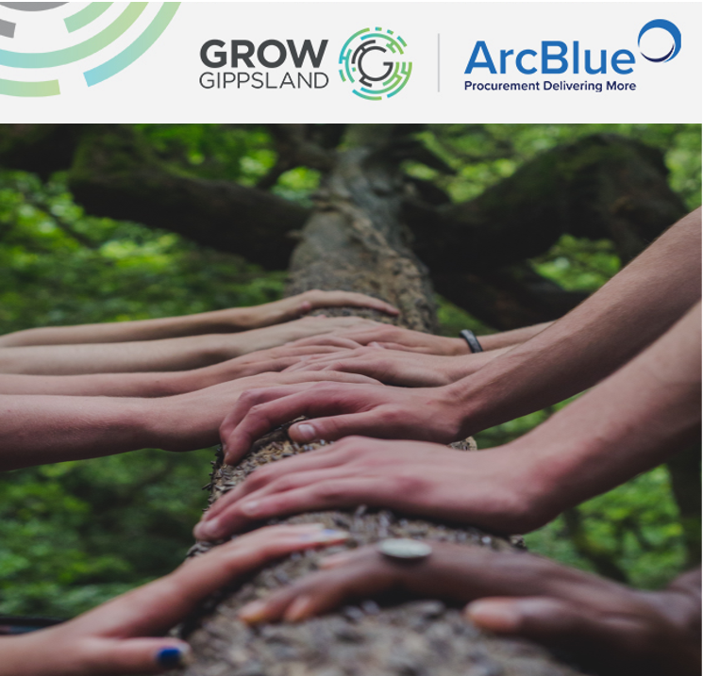
Inclusive Employment Defined
GROW Gippsland Inclusive Employment Toolkit

January 2020

GROW Gippsland – Supporting Inclusive Employment
GROW Gippsland seeks to make a positive social impact by maximising opportunities for those who may otherwise have barriers to finding work.
In Gippsland, the following target groups have been identified and are the focus of GROW Gippsland activities:
- Young people
- Transitioning workers
- Aboriginal people
- People with disability
- Long-term unemployed, and
- Culturally and Linguistically Diverse (CALD), New Migrant and refugee population.
If you are looking to employ people with barriers to work, GROW Gippsland provides access to resources, networks and support services to assist your business through the process.

What is Inclusive Employment?
‘Inclusive Employment’ can be defined as all efforts that promote fair and equitable access to decent employment, ensuring satisfactory pay and conditions, career prospects and opportunities for social integration (BSL 2015).
For GROW Gippsland this means actively setting and meeting targets for employing disadvantaged jobseekers.
How Does Inclusive Employment Relate to the Victorian Government’s Social Procurement Framework ?
The Victorian Government has established Victoria’s Social Procurement Framework (SPF), that applies to the procurement of all goods, services and construction by, or on behalf of, Victorian Government departments and agencies from 1 September 2018. Under the SPF, inclusive employment is when suppliers provide direct employment for disadvantaged Victorians.
Paid employment builds confidence and self-esteem; enables more independent and stable lifestyles and fosters social and community participation.
From a whole of state perspective, the SPF looks to suppliers to advance the following outcomes:
- Employment of Victorian Aboriginal people and Victorians with disability;
- Gender equality including greater opportunities for women in non-traditional or leadership roles, or support for at-risk women;
- Training and employment for long-term unemployed people, disengaged youth, single parents, migrants, refugees, workers in transition, and people in regions with entrenched disadvantage; and
- Sustainable regional economies and communities.
In the Gippsland region; GROW Gippsland’s primary activities support the following groups with barriers to work:
- Young people
- Transitioning workers
- Aboriginal people
- People with disability
- Long-term unemployed, and
- Culturally and Linguistically Diverse (CALD), New Migrant and refugee population.

For more information on how Inclusive Employment relates to the Social Procurement Framework, download the Victorian Government’s Social Procurement Framework Supplier Inclusive Employment Fact Sheet here: https://buyingfor.vic.gov.au/sites/default/files/2018-09/inclusive_employment_2018.pdf

